## INCOME TAX ANALYSER USING TKINTER

**A MINI PROJECT REPORT**

***Submitted by***

### HEMANTH KUMAR B 212220040047

***in partial fulfillment for the award of the degree of***

### BACHELOR OF ENGINEERING IN

**COMPUTER SCIENCE AND ENGINEERING**



### SAVEETHA ENGINEERING COLLEGE,THANDALAM

### ANNA UNIVERSITY : CHENNAI- 600 025

**DECEMBER 2022**

## ANNA UNIVERSITY, CHENNAI- 600 025 BONAFIDE CERTIFICATE

Certified that this Mini Project report **“INCOME TAX ANALYSER USING TKINTER”** is the bonafide work **HEMANTH KUMAR B (212220040047)** who carried out the mini project work under my supervision.

**SIGNATURE SIGNATURE**

**Dr V. Umarani, M.E, Ph.D, Dr G. Nagappan, M.E, PhD,**

Associate Professor Professor

**SUPERVISOR HEAD OF THE DEPARTMENT**

Dept of Computer Science and Dept of Computer Science and

Engineering, Engineering,

Saveetha Engineering College, Saveetha Engineering College,

Thandalam, Chennai 602105. Thandalam, Chennai 602105.

DATE OF THE VIVA VOCE EXAMINATION: ……………………….

**INTERNAL EXAMINER EXTERNAL EXAMINER**

# ACKNOWLEDGEMENT

We express our deep sense of gratitude to our honorable and beloved Founder President **Dr N.M.VEERAIYAN**, our President **Dr SAVETHA RAJESH**, our Director **Dr S.RAJESH** and other management members for providing the infrastructure needed.

We express our wholehearted gratitude to our principal, **Dr N. DURAIPANDIAN**, for his whole hearted encouragement in completing this project.

We convey our thanks to **Dr G. NAGAPPAN**, Professor and Head of the Department of Computer Science and Engineering, Saveetha Engineering College, for his kind support and for providing the necessary facilities to carry out the project work.

We would like to express our sincere thanks and deep sense of gratitude to our Supervisor **Dr V. UMARANI, M.E, Ph.D** Associate Professor, Department of Computer Science and Engineering, Saveetha Engineering College and our Project Coordinator, **Dr M. VIJAY ANAND, M.E, Ph.D** Professor, Department of Computer Science and Engineering, Saveetha Engineering College, for their valuable guidance, suggestions and constant encouragement that paved the way for the successful completion of the project work and for providing us necessary support and details at the right time and during the progressive reviews.

# Table of Contents

**Chapter No Title Page Number**

Abstract 1

List of Figures 2

List of abbreviations 3

1. INTRODUCTION
   1. Overview of the project 5
   2. Scope and Objective 5
2. LITERATURE SURVEY
   1. Introduction 7
   2. Literature Survey 7
3. SYSTEM DESIGN
   1. Introduction 9
   2. Existing System 10
   3. Proposed System 10
   4. System Architecture Diagram 11
   5. Data Flow Diagram 11
   6. System Requirements 12
4. **IMPLEMENTATION**

|  |  |  |
| --- | --- | --- |
|  | **4.1 Module Description** | **15** |
| **4.2 Module Implementation** | **15** |
| **4.2.1 Getting the data** | **16** |
| **4.2.2 Attribute Types** | **16** |
| **4.3 Feasibility Study** | **18** |
| **4.4 Results and Analysis** | **18** |
| **4.5 System Design and Testing Plan** | **19** |
| **5** | **CONCLUSION** |  |
|  | **5.1 Conclusion** | **21** |
|  | **5.2 Future Enhancement** | **21** |
|  | **Appendix A-Sample Coding** | **22** |
|  | **Appendix B-Sample Output** | **29** |
|  | **References** | **33** |

# ABSTRACT

The goal of my project is to built a GUI (Graphical User Interface) application to calculate the liable tax of a salaried person.This application aims at providing a user-friendly approach to calculate the payable tax without digging into complex details and calculations.

In this project, income tax calculator helps the user to manage their taxes and choose the best suitable tax regime (old or new). This calculator gives user the opportunity to check how much they can save by opting one Tax system over the other.

The purpose of this research was to determine the suitability of the Income Tax Law Number 36 of 2008 with the calculation of income tax for CV. K's fisheries collectors. The analytical method used in this research is a descriptive / comparative analysis, namely an analysis that describes, and compares the calculation of corporate income tax, according to the company with the calculation of income tax according to the tax law.

### LIST OF FIGURES

|  |  |  |  |
| --- | --- | --- | --- |
| **S.NO** | **FIGURE NO** | **TITLE** | **PAGE NO** |
| 1 | 3.1 | Regression Diagram | 9 |
| 2 | 3.2 | Architecture Diagram | 11 |
| 3 | 3.3 | Flow Diagram | 11 |
| 4 | 4.1 | Validation Testing Diagram | 20 |
| 5 | 5.A.1 | Login Screen | 19 |
| 6 | 5.A.2 | Python Implementation Code- 1 | 22 |
| 7 | 5.A.3 | Python Implementation Code- 2 | 23 |
| 8 | 5.A.4 | Python Implementation Code - 3 | 24 |
| 9 | 5.A.5 | Python Implementation Code - 4 | 25 |
| 10 | 5.A.6 | Python Implementation Code - 5 | 26 |
| 11 | 5.B.1 | Home Page View | 27 |
| 12 | 5.B.2 | Login Page View | 28 |
| 13 | 5.B.3 | Result view | 29 |
| 14 | 5.B.4 | Report View | 30 |

**LIST OF ABBREVIATIONS**

**APBN ---[Anggaran Pendapatan](https://www.lawinsider.com/dictionary/apbn)** Belanja Negara

**FY** Financial Year AS--Assessment Year

**CHAPTER 1**

**INTRODUCTION**

Tax has a very large contribution in the development of the country in India. More than 75% of APBN revenues or the State Revenue and Expenditure budget are received from taxes. Construction of public facilities financed by the state. In addition, taxes are also useful as a means of examining welfare. Taxes collected from taxpayers are used to subsidize disadvantaged people.

The calculator has a very simple design, any user who is not aware of basic calculations involved in calculating income tax can easily operate.At first users need to click on the Start button tat user to proceed. Then Users needs to enter their details like Name, Contact No. And Email Id for record purposes.

The type of tax with a large contribution to the State Revenue and Expenditure budget , namely income tax. Where taxes are paid on the subject of tax obtained, or obtained in the tax year . Taxes that are included in the destination tax category that do not look to anyone Taxes are impose but more towards object taxes. The tax subject can be charged as a on personal tax,compulsory tax agency and Permanent Business Entity.

### Overview of the Project

The Income and Tax Calculator service enables both registered and unregistered e-Filing users to calculate tax as per the provisions of Income Tax Act, Income-tax rules, Notifications etc. by providing inputs with respect to income(s) earned and deductions claimed as per the Act. This service also provides a calculation of tax under the old or new tax regime with a comparison of tax as per the old and new regime

There are two tabs – **Basic Calculator** and **Advanced Calculator**. The **Basic Calculator** tab is selected by default.

### SCOPE AND OBJECTIVE

* + 1. **SCOPE:**

1. For the purposes of this Standard, taxes on income include all domestic and Indian tax rates which are based on taxable income.
2. This Standard does not specify when, or how, an enterprise should account for taxes that are payable on distribution of dividends and other distributions made by the enterprise
3. This Standard should be applied in accounting for taxes on income. This includes the determination of the amount of the expense or saving related to taxes on income in respect of an accounting period and the disclosure of such an amount in the financial statements.
   * 1. **OBJECTIVE**

The objective of this Standard is to prescribe accounting treatment for taxes on income. Taxes on income is one of the significant items in the statement of profit and loss of an enterprise. In accordance with the matching concept, taxes on income are accrued in the same period as the revenue and expenses

Firstly, there are differences between items of revenue and expenses as appearing in the statement of profit and loss and the items which are considered as revenue, expenses or deductions for tax purposes.

## CHAPTER 2

## LITERATURE SURVEY

### Literature Survey

## **“Annual individual income tax calculator.”**

* This research paper on Individual income tax is an important source of revenue for

government and the basis of financing and functioning of a state's organization. In the

* Republic of Serbia this tax category holds an important position in the tax system

Individual income tax law and the Regulations of tax return forms for individual income tax calculation paid by tax bill. Basic elements of the individual income tax which need to be defined are taxpayer, tax base and tax rate.

# “**Tax Avoidance and the Deadweight Loss of the Income Tax**”

Traditional analyses of the income tax greatly underestimate deadweight losses by

ignoring its effect on forms of compensation and patterns of consumption. The full deadweight loss is easily calculated using the compensated elasticity of taxable income to changes in tax rates because leisure, excusable income, and deductible consumption are a Hicksian composite good. Microeconomics estimates imply a deadweight loss of as much as 30% of revenue or more than ten times Harberger's classic 1964 estimate.

# “**User-friendly Guidelines for Tax & Statutory Management in India”**

According to Economic Survey 2015-16 the proportion of economically active population (15-59  years J has increased from 57. 7 % to 63.3 % during the 1991-2013 periods. The employment growth in  the organized sector (public and private combined) increased by 2 %. Though huge numbers of people  are working in India and they are paying their regular taxes by consulting financial experts but many of  them are completely blank about the working and calculation of this part of their income. Considering  this we decided to work on this topic and prepare user{friendly guidelines which can be referred by  anyone. Examples have been cited for tax calculation related to salary. From the start to end process of  the salary with taxation and statutory deduction will definitely help the working professional .

**“Single Window Performing Multiple Tax Operations”**

The research paper deals with computerizing the process of tax payment. The entire process of tax payment will be maintained in an automated way. The main objective of this project is to reduce the time consumption. The income tax system has been categorized into three groups according to the mode of payment to the central government, state government, and the municipality.

# **“**Tax Planning And Equivalent Returns: A Case Of Small Business owner”

The Research paper deal with Indian tax saving and investment of savings for the future is the bigger concern. Most investors invest in GPF, Fixed Deposits, Recurring Deposits, Real Estate, Gold, etc. without considering the consequences of these alternatives on tax liability. For saving tax, Indians buy insurance policies and invest in GPF, PPF, etc. As per sec 80C of the Income tax act saving up to Rs 150000 in some of the instruments like GPF, PPF, ELSS, Life insurance premiums, etc. are tax deductible i.e., taxable income is reduced by this amount to calculate the tax liability. This Case Study will help the students and practitioners of wealth management to learn the practical aspects of dealing with the tax planning of small investors, particularly the salaried employees in the lower middle-class category. The case will also help to learn the calculation of the equivalent returns and comparison of various investment alternatives.

## CHAPTER 3

## SYSTEM DESIGN

### Introduction

Income tax is an annual tax on income. The Indian Income Act Provides that in respect of total income of the previous year of every person income tax shall be charged for the corresponding assessment year at the rates laid down by the Financial act for that for that for the purpose of charge of income tax and computation of total income all incomes shall be classified under

The following heads of income:

Salaries.

Income from house property.

Profits or gains of business or profession. Capital gains.

Income from other sources.

**Regression Based Model**

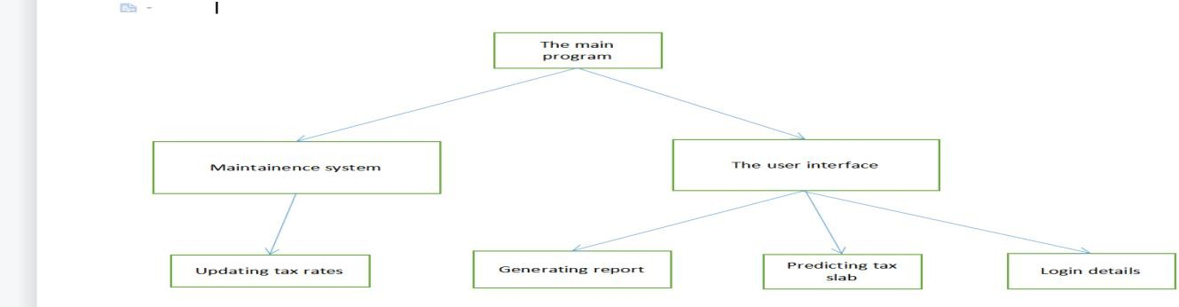

Fig. 3.1 – Regression Diagram.

### Existing System

Income Tax Calculator to know the taxes to be paid for a given Income and to compare Old vs New tax regimes (scheme) for IT declaration with your employer or to know your tax exposure

1. Online tool provided by income tax website for calculating tax.
2. It helps to calculate the tax for the financial year.
3. It provides basic information for paying taxes.
4. They didn’t provide any comparison to old and new tax regime**.**

### Proposed System

The Union Budget has left individuals confused with the choice of the tax regime. Both old and new tax regimes require a proper assessment before choosing one.

1.The tool works completely offline and compare Old tax slabs and New tax slabs.

2.Recommend which tax slab is better to follow.

3.Calculate how much tax have to pay for the financial year

4.It reduce time consuming and provide money saving.

### System Architecture Diagram

### Data Flow Diagram

Fig. 3.2 – Architecture Diagram.

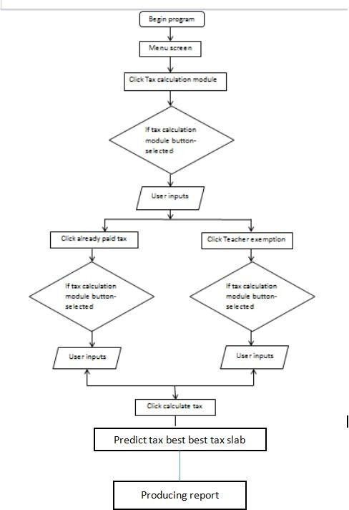

Fig. 3.3 – Flow Diagram.

### System Requirements:

**Software Description:**

### Visual Studio

**Visual Studio** is an [integrated development environment](https://en.wikipedia.org/wiki/Integrated_development_environment) (IDE) from [Microsoft](https://en.wikipedia.org/wiki/Microsoft). It is used to develop [computer programs](https://en.wikipedia.org/wiki/Computer_program) including [websites](https://en.wikipedia.org/wiki/Web_site), [web apps](https://en.wikipedia.org/wiki/Web_app), [web](https://en.wikipedia.org/wiki/Web_service) services and [mobile apps](https://en.wikipedia.org/wiki/Mobile_app). Visual Studio uses Microsoft software development platforms such as [Windows API](https://en.wikipedia.org/wiki/Windows_API), [Windows Forms](https://en.wikipedia.org/wiki/Windows_Forms), [Windows Presentation](https://en.wikipedia.org/wiki/Windows_Presentation_Foundation) Foundation, [Windows Store](https://en.wikipedia.org/wiki/Windows_Store) and [Microsoft Silverlight](https://en.wikipedia.org/wiki/Microsoft_Silverlight). It can produce both [native](https://en.wikipedia.org/wiki/Machine_code) code and [managed code](https://en.wikipedia.org/wiki/Managed_code).

Visual Studio includes a [code editor](https://en.wikipedia.org/wiki/Code_editor) supporting [IntelliSense](https://en.wikipedia.org/wiki/IntelliSense) (the [code](https://en.wikipedia.org/wiki/Code_completion) completion component) as well as [code refactoring](https://en.wikipedia.org/wiki/Code_refactoring). The integrated debugger works both as a source-level debugger and a machine-level debugger. Other built-in tools include a [code profiler](https://en.wikipedia.org/wiki/Profiling_(computer_programming)), designer for building [GUI](https://en.wikipedia.org/wiki/GUI) applications, [web](https://en.wikipedia.org/wiki/Web_designer) designer, [class](https://en.wikipedia.org/wiki/Class_(computing)) designer, and [database schema](https://en.wikipedia.org/wiki/Database_schema) designer. It accepts plug-ins that expand the functionality at almost every level—including adding support for [source](https://en.wikipedia.org/wiki/Source_control) control systems.

# Python

# Python is a computer programming language often used to build websites and software, automate tasks, and conduct data analysis. Python is a general-purpose language, meaning

# it can be used to create a variety of different programs and isn’t specialized for any specific problems. This versatility, along with its beginner-friendliness, has made it one of the most-

# used programming languages today.

It has a **simple syntax** that mimics natural language, so it’s easier to read and understand. This makes it quicker to build projects, and faster to improve on them.

It’s **versatile**. Python can be used for many different tasks, from web development to machine learning.

It’s **beginner friendly**, making it popular for entry-level coders.

It’s **open source**, which means it’s free to use and distribute, even for commercial purposes.

**Tkinter**

Tkinter is an open source, portable graphical user interface (GUI) library designed for use in Python scripts.

Tkinter relies on the Tk library, the GUI library used by Tcl/Tk and Perl, which is in turn implemented in C. Therefore, Tkinter can be said to be implemented using multiple layers.

Several competing GUI toolkits are available to use with the Python language, namely:

* + 1. **Hardware Requirements**
* For developing this project, the following Hardware components are required:
  + - 1. Internet or LAN Connections
      2. Processor with speed of 500MHz
      3. RAM – Minimum 2GB
      4. A Basic Laptop/Computer System/Mobile phone.
    1. **Software Requirement**
* For developing this project, the following Soft wares are required :
  + - 1. A Integrated Development Environment (IDE) like VS Code, etc.
      2. JavaScript for application to run on visual studio platform.
      3. CSS for design of the application.
      4. HTML for the framework purpose.

**CHAPTER 4**

**IMPLEMENTATION AND ANALYSIS**

### List Of Module Description

### Income tax calculator application various modules are integrated together to get a single

### fully fledged application. As various modules are involved, each one should be analyzed separately and implemented. The modules involved in this :

* USER LOGIN
* INCOME AND DEDUCTION DETAILS
* TAX CALCULATION
* PREDICTION OF TAX SLAB
* REPORT GENERATION.

### Module Implementation

* + 1. **USER LOGIN:**

Creating user login interface for entering name,contact number,Gmail id checking the entered details are in correct format or not Providing reference to enter the details

* It makes user to enter the details on the text boxes
* It validates whether enter details are in correct format or not
* It stores this entered details for producing the report at the end.

### INCOME AND DEDUCTION DETAILS

* For Income text box:
* The user has to enter the sum of annual income details that is how much he earned throughout the financial year
* For Deduction text box:
* The user has to enter the sum of all deduction that occured throughtout the financial year

### TAX CALCULATION

* Calculating tax for each Tax slab according to the tax rate mentioned by income tax of India for income generated after removal deduction mentioned previously

### PREDICTION OF TAX SLAB

* After calculation of each tax slab and comparing both tax slab payable amount and predicting the tax slab which provides the low payable amount .

### REPORT GENERATION

* Generating a PDF report of calculation of tax slabs and mentioning the tax slab which is better to follow .

### Feasibility Study

A study is undertaken on all the factors relevant to the project, such as legal, technical, economic, and operational aspects. Many project managers undertake a feasibility study to determine the advantages and disadvantages of carrying out a project. A feasibility study happens at the planning stage before investing time, money, and other resources into the project.

### Results and Analysis

Income tax is based on your annual income earned from various sources including your salary . profits from business, gains from selling capital assets like property, rental income, and interest/dividend/commission income. There are various slabs of income tax rates based on earnings and the rates get progressively higher for taxpayers with higher incomes.

So, if you’re an entrepreneur who is looking to easy to calculate income tax, then this article will provide you with a complete guide and professional’s tips on how to do it.

### System Design and Testing Plan

This section provides an elaboration of the detailed technical system design as being a comprehensive solution based on utilizing the diet plan, food recommendations, calorie counter, weight loss per week using android development.

It gets the basic details and calculate the calorie count and food diet suggestion to the user based on the calorie count and the fitness maintaining based on the proteins and the calories. The contents of this section will focus on illustrating the data workflow.

* + 1. **Types of Testing**

The purpose of testing is to get errors. Testing is that the process of trying to get every conceivable fault or weakness during a work product. It provides how to see the functionality of components, sub-assemblies, assemblies and/or a finished product it's the method of exercising.

software with the intent of ensuring that the software meets its requirements and user expectations and doesn't fail in an unacceptable manner. There are various sorts of test. Each test type addresses a selected testing requirement. The various types of testing that follows are listed as below.

**UNIT TESTING**

Unit testing involves the planning of test cases that validate that the interior program logic is functioning properly, which program inputs produce valid outputs.

All decision branches and internal code flow should be validated. it's the testing of individual software units of the appliance.

It is done after the completion of a private unit before integration. this is often a structural testing, that relies on knowledge of its construction and is invasive. Unit tests perform basic tests at component level and test a selected business process, application, and/or system configuration.

**INTEGRATION TESTING**

Integration tests are designed to check integrated software components to work out if they really run together program. Testing is event driven and is more concerned with the essential outcome of screens or fields.

Integration tests demonstrate that although the components were individually satisfaction, as shown by successfully unit testing, the mixture of components is correct and consistent. Integration testing is specifically aimed toward exposing the issues that arise from the mixture of components.

**VALIDATION TESTING**

Validation testing is that the process of ensuring if the tested and developed software satisfies the client/user needs. The business requirement logic or scenarios need to be tested intimately. All the critical functionalities of an application must be tested here.

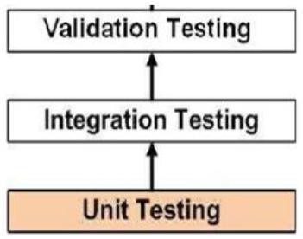

Fig. 4.1 – Validation Testing Diagram.

**SYSTEM TESTING**

System testing of software or hardware is testing conducted on an entire, integrated system to gauge the system's compliance with its specified requirements. System testing falls within the scope of recorder testing, and intrinsically, should require no knowledge of the inner design of the code or logic.

As a rule, system testing takes, as its input, all of the "integrated" software components that have successfully passed integration testing and also the software itself integrated with any applicable hardware system(s).

System testing may be a more limited sort of testing; it seeks to detect defects both within the "inter-assemblages" and also within the system as an entire. System testing is performed on the whole system within the context of a Functional Requirement Specification(s) (FRS) and/or a System Requirement Specification (SRS). System testing tests not only the planning, but also the behavior and even the believed expectations of the customer. it's also intended to check up to and beyond the

bounds defined within the software/hardware requirements specification(s).

## CHAPTER 5

**CONCLUSION AND FUTURE ENHANCEMENTS**

### Conclusion

This application makes it very easy for the user to calculate the income tax, with these simple steps, you can perform the income tax calculation. As we all know It’s important to pay your taxes and file your IT returns on time.

* A simple GUI for income tax calculation is developed for users.
* It helps to learn about income tax rules for filling the ITR.
* It provide sugession to select tax slab over the income.

**5.2 Future Enhancement**

In the future scope,the application can enhance its functionality by adding image recognition of deduction reports.

To analyze the report and concluding deduction is considerable or not.Including an voice assistant to instruct for entering the details.

## Appendix A

### Sample Coding

**Manual Entry page:**

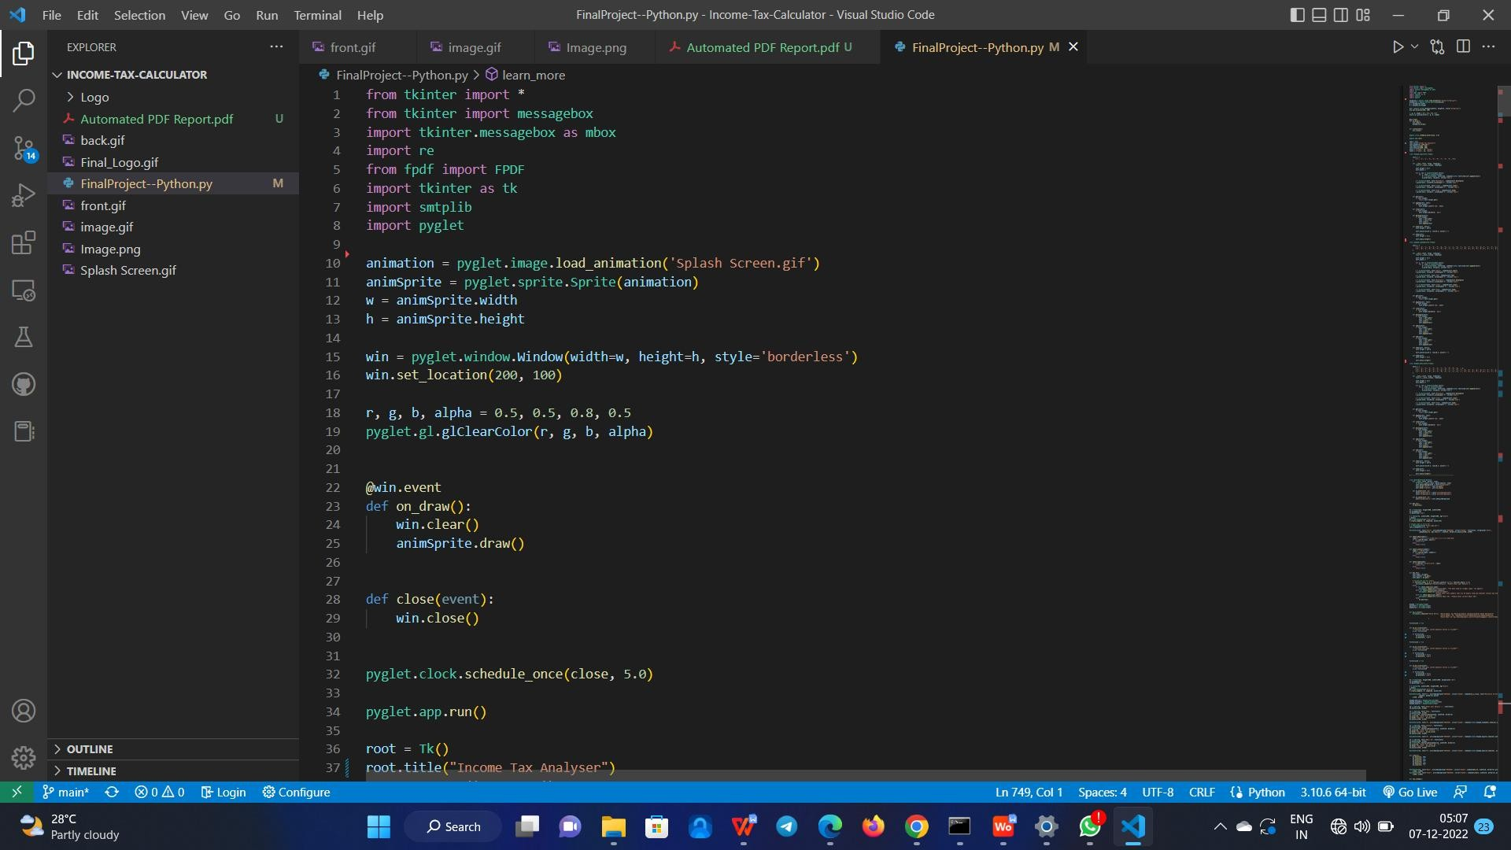

Fig. 5.A.1 – Python implementation

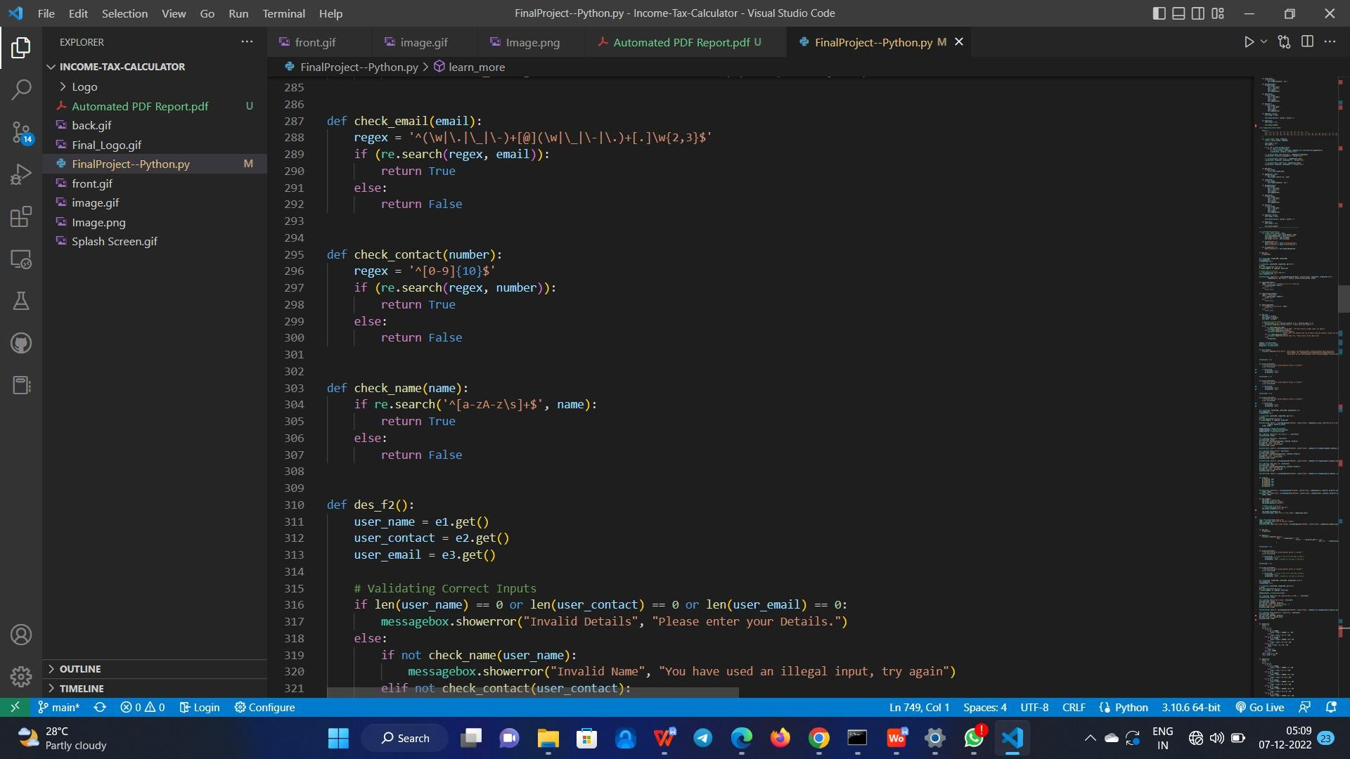

Fig. 5.A.2 – validation of format

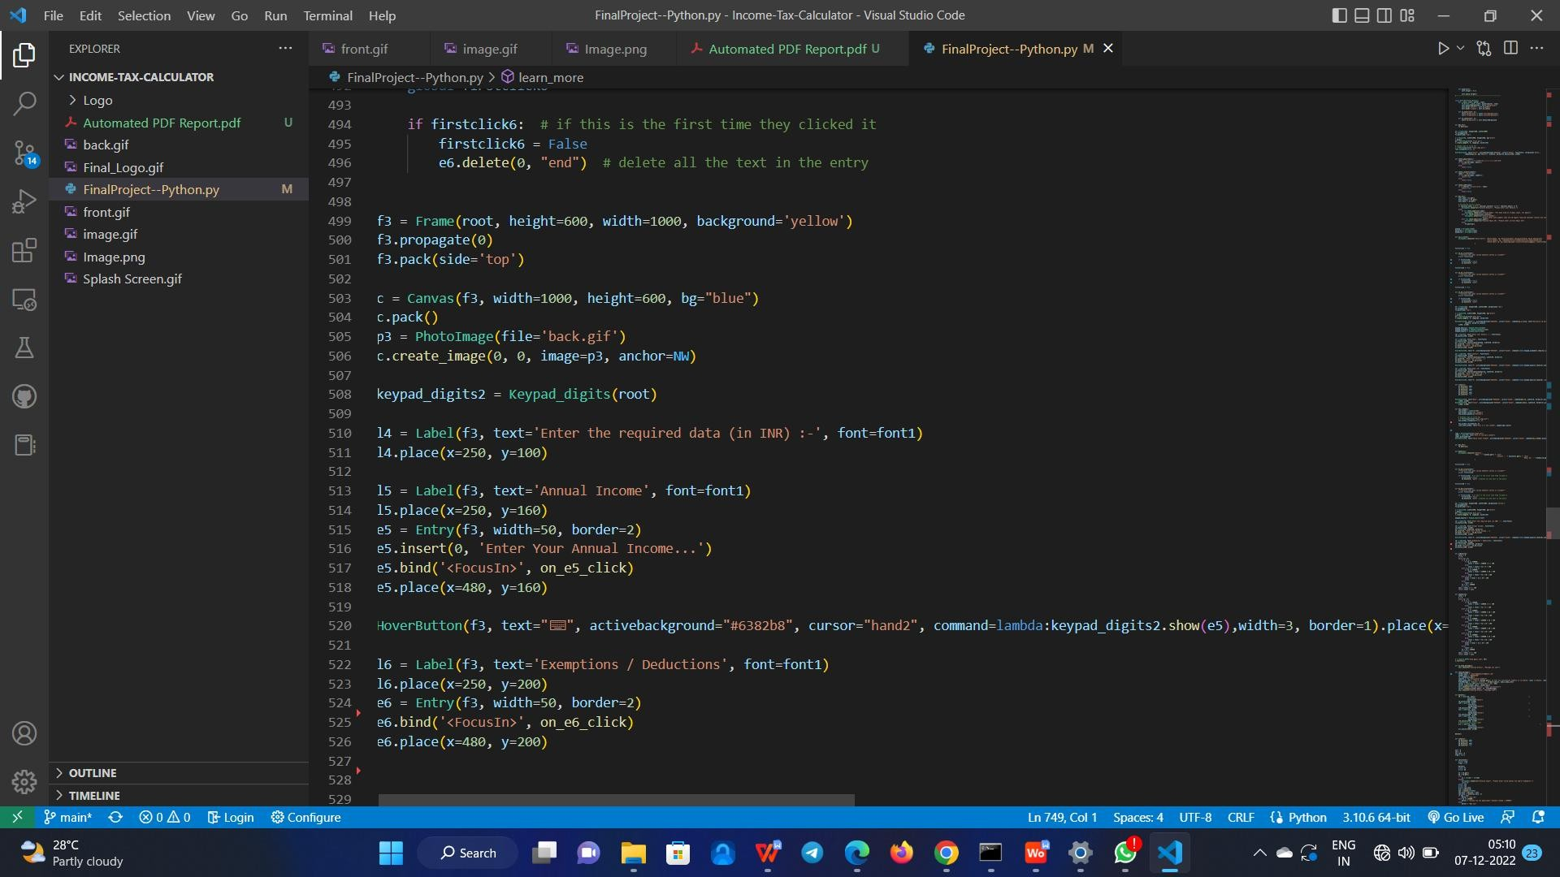

Fig. 5.A.3 - Annual and deduction entry

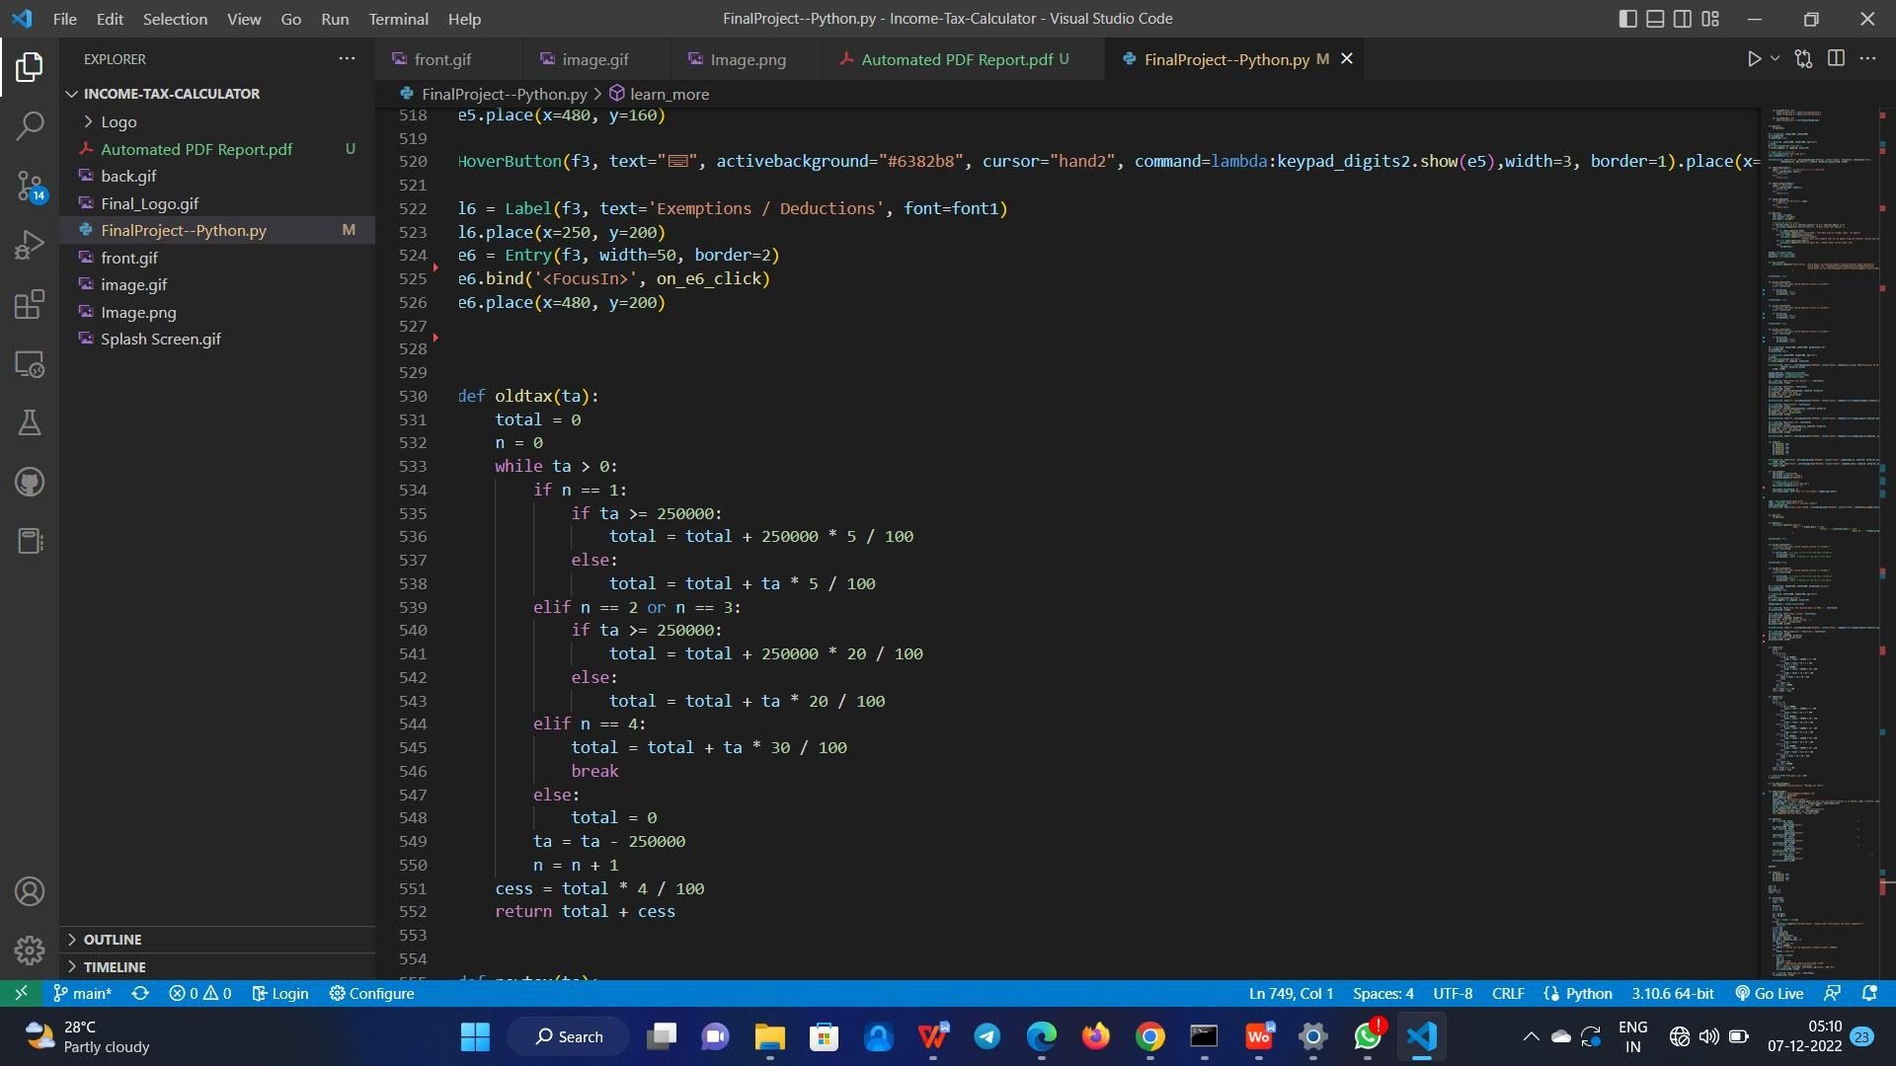

Fig. 5.A.4 - old tax slab calculation

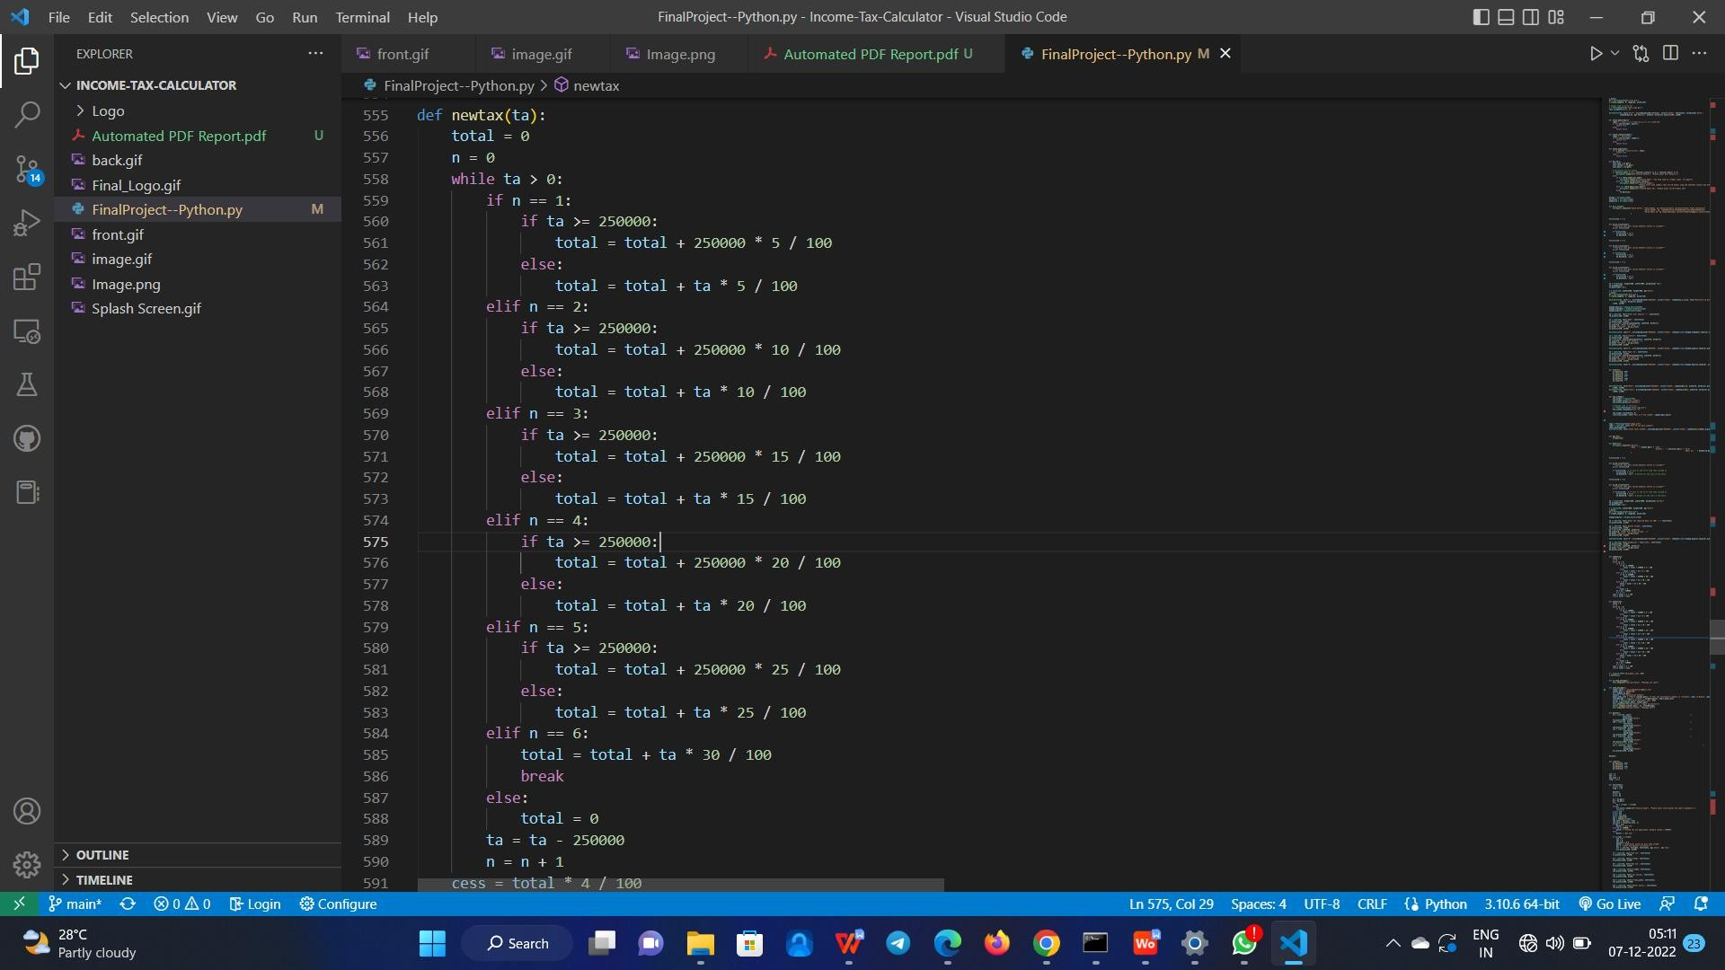

Fig. 5.A.5 - new tax calculation

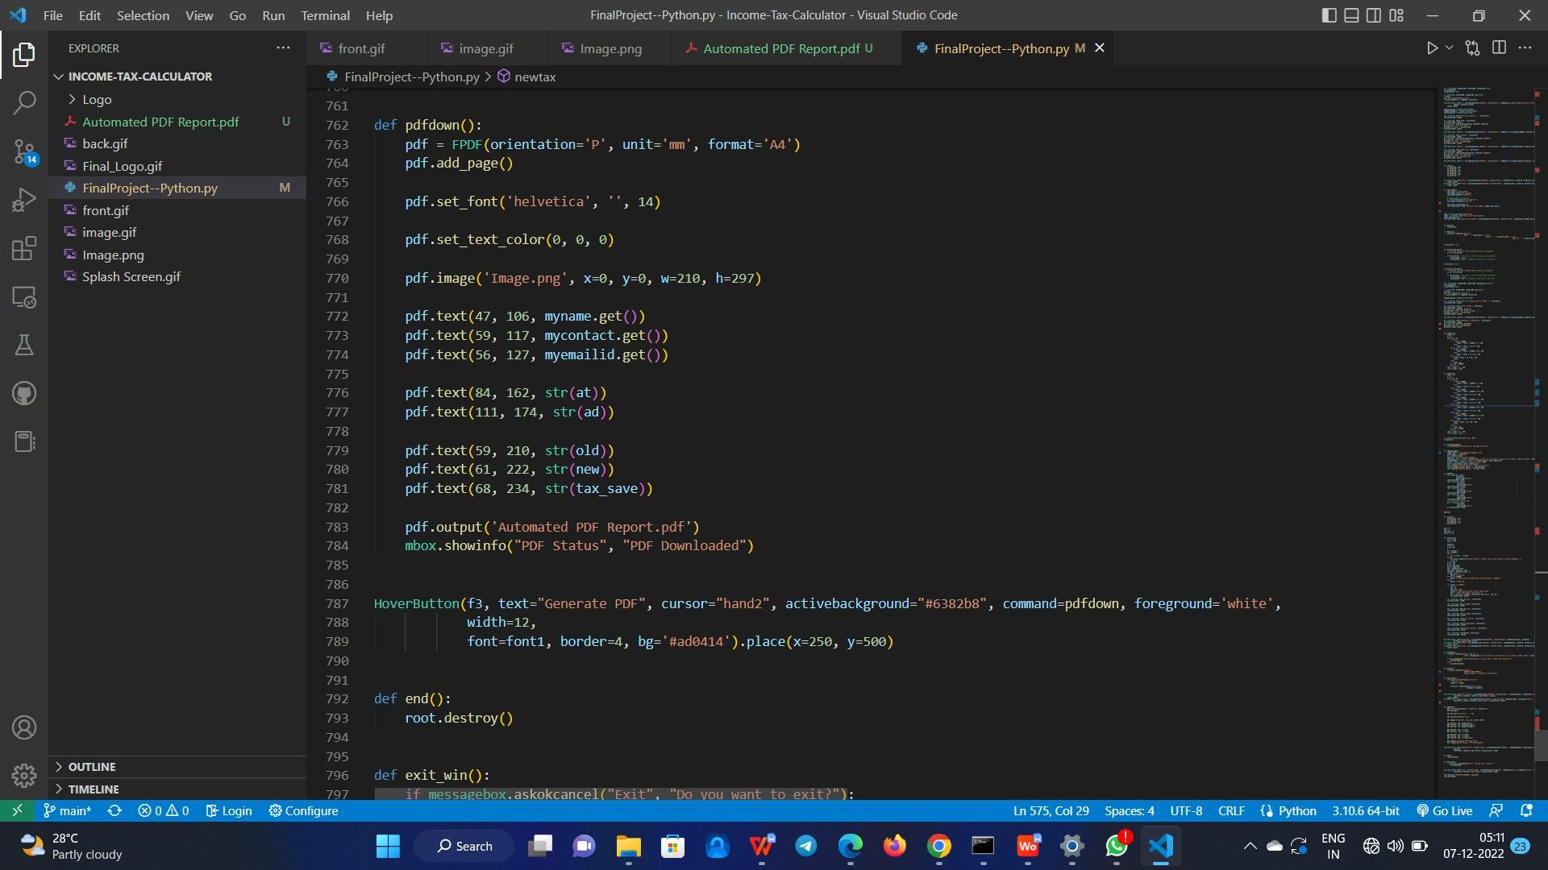

Fig. 5.A.6 - Generating report

## Appendix B

### Sample Output

**Start page:**

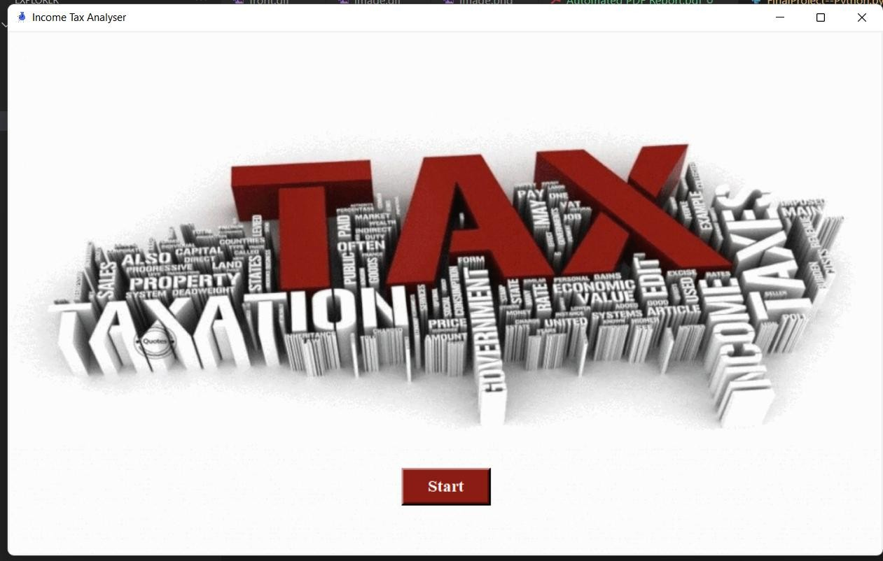 Fig. 5.B.1 - Start Page View.

**Login Page:**

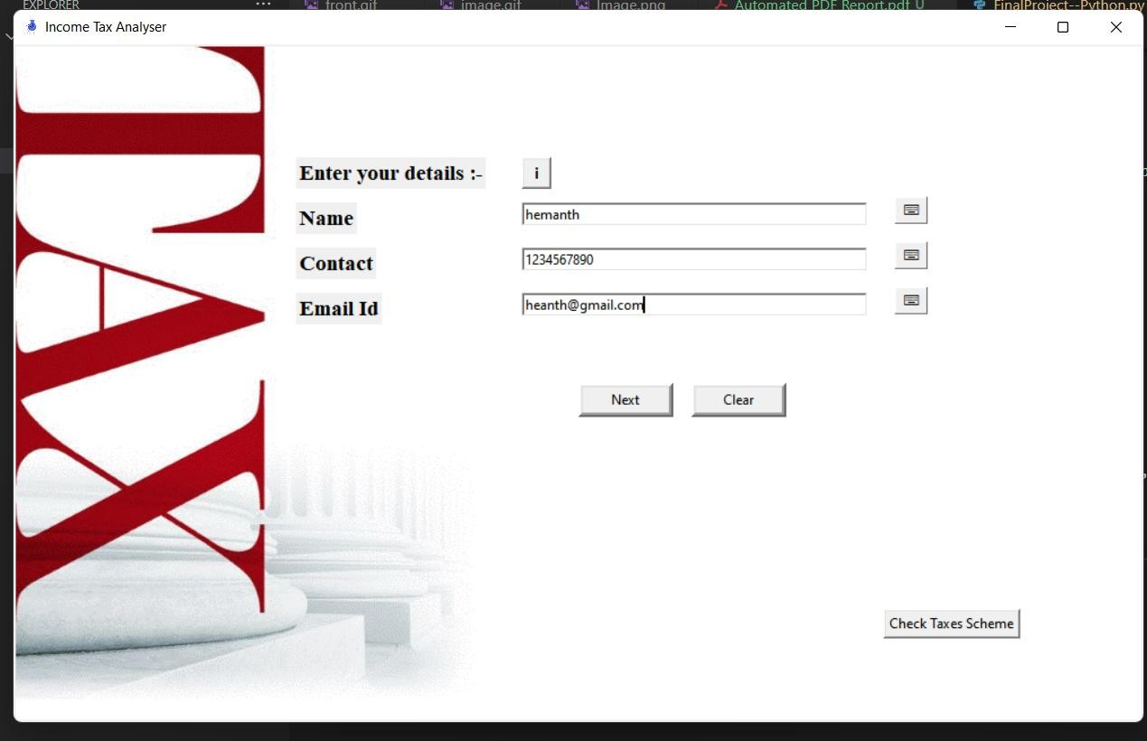

Fig. 5.B.2 - Login Page View.

**Introdution Page**

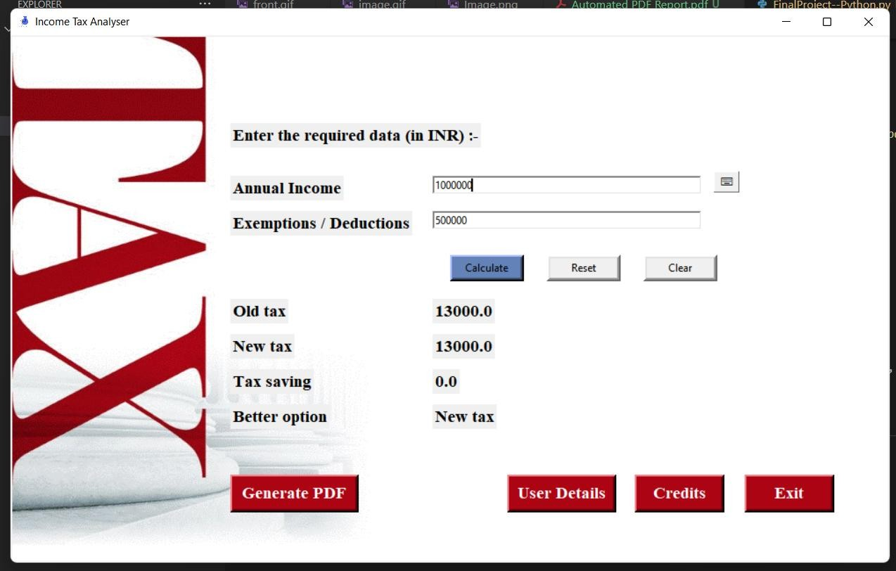

Fig. 5.B.3 – Result View.

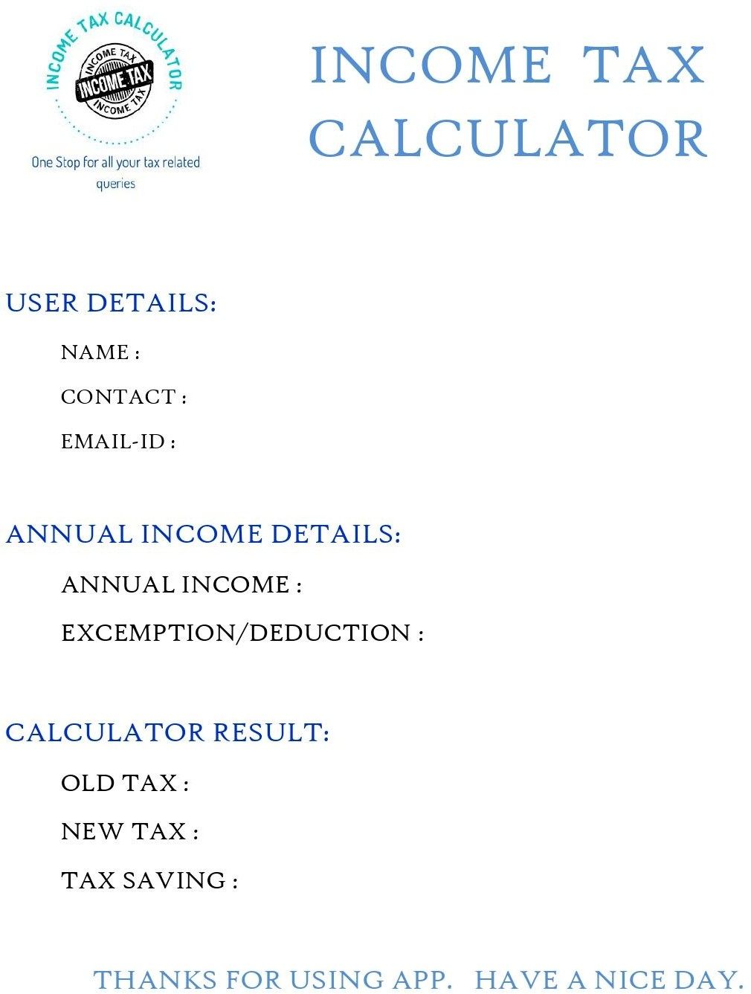

Fig. 5.B.4 - Report View.

## References

* Literature Review On paisa bazzar[ Nov 2020],
* INCOME TAX OF INDIA.
* https://[www.incometax.gov.in/](http://www.incometax.gov.in/)
* Alm, J. (2012). “Measuring, Explaining, and Controlling Tax Evasion: Lessons from Theory.
* Experiments, and Field Studies.” International Tax and Public Finance 19 (1): 54-77.
* Lymer, A., and Oats, L. (2009). Taxation: Policy and Practice. 16th ed. Birmin Fiscal.
* Martinez-Lopez, D. (2012). The underreporting of income by self- employed workers in Spain. Seville: SpringerLink.com. Mazur, J. and Plumley, A. (2007). “Understanding the Tax Gap.” Presentation to National Tax Association Spring Meeting. May. Washington, DC.
* TKINTER DOCUMENTATION.
* FILEDIR available at: https://filedir.com/android/finance/pension- calculator-10947540.html last accessed 23-12-2015.
* Apkpureavailable at: <http://apkpure.science/64-the-pension-> calculator/com.ipf.ipfapp last accessed 1-11-2015.
* Googleat:https://play.google.com/store/apps/details?id=com.subroto.zak atcal last accessed 15-12-2015.
* Google play available at:
* https://play.google.com/store/apps/details?id=com.avistechltd.zakatcalc ulator last accessed 10-12-2015.
* Google play available at:
* https://play.google.com/store/apps/details?id=ee.smkv.calc.loan last accessed